Abstract Modifier:
- Abstract is the modifier applicable only for methods and classes but not for variables.
Abstract Methods:
- Even though we don’t have implementation still we can declare a method with abstract modifier. That is abstract methods have only declaration but not implementation. Hence abstract method declaration should compulsory ends with semicolon.
EXAMPLE:
- Child classes are responsible to provide implementation for parent class abstract methods.
EXAMPLE:

PROGRAM:

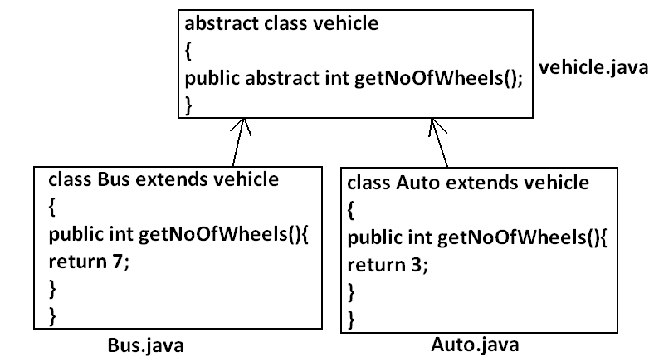

- The main advantage of abstract methods is , by declaring abstract method in parent class we can provide guide lines to the child class such that which methods they should compulsory implement.
- Abstract method never talks about implementation whereas if any modifier talks about implementation it is always illegal combination.
- The following are the various illegal combinations for methods.
Diagram:
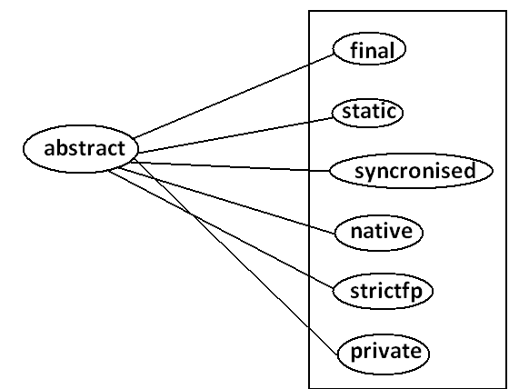
- All the 6 combinations are illegal.
Page|| 1
Abstract class:
- For any java class if we are not allow to create an object such type of class we have to declare with abstract modifier that is for abstract class instantiation is not possible.
Example:
abstract class Test
{
public static void main(String args[]){
Test t=new Test();
}}
Output:
Compile time error.
D:\Java>javac Test.java
Test.java:4: Test is abstract; cannot be instantiated
Test t=new Test();
What is the difference between abstract class and abstract method?
- If a class contain at least on abstract method then compulsory the corresponding class should be declare with abstract modifier. Because implementation is not complete and hence we can’t create object of that class.
- Even though class doesn’t contain any abstract methods still we can declare the class as abstract that is an abstract class can contain zero no of abstract methods also.
Example1: HttpServlet class is abstract but it doesn’t contain any abstract method.
Example2: Every adapter class is abstract but it doesn’t contain any abstract method.
Example1:
class Parent
{
public void methodOne();
}
Output:
Compile time error.
D:\Java>javac Parent.java
Parent.java:3: missing method body, or declare abstract
public void methodOne();
Example2:
class Parent
{
public abstract void methodOne(){}
}

Output:
Compile time error.
Parent.java:3: abstract methods cannot have a body
public abstract void methodOne(){}
Example3:
class Parent
{
public abstract void methodOne();
}
Output:
Compile time error.
D:\Java>javac Parent.java
Parent.java:1: Parent is not abstract and does not override abstract method methodOne() in Parent
class Parent
- If a class extends any abstract class then compulsory we should provide implementation for every abstract method of the parent class otherwise we have to declare child class as abstract.
Example:
abstract class Parent
{
public abstract void methodOne();
public abstract void methodTwo();
}
class child extends Parent
{
public void methodOne(){}
}
Output:
Compile time error.
D:\Java>javac Parent.java
Parent.java:6: child is not abstract and does not override abstract method methodTwo() in Parent
class child extends Parent
- If we declare class child as abstract then the code compiles fine but child of child is responsible to provide implementation for methodTwo().
What is the difference between final and abstract?
- For abstract methods compulsory we should override in the child class to provide implementation. Whereas for final methods we can’t override hence abstract final combination is illegal for methods.
- For abstract classes we should compulsory create child class to provide implementation whereas for final class we can’t create child class. Hence final abstract combination is illegal for classes.
- Final class cannot contain abstract methods whereas abstract class can contain final method.

Example:
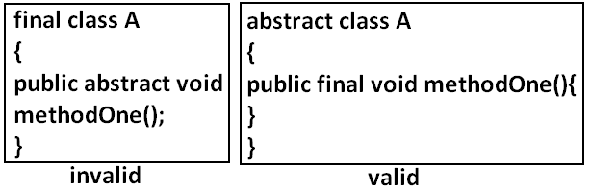
Note:
- Usage of abstract methods, abstract classes and interfaces is always good programming practice.
Strictfp:
- strictfp is the modifier applicable for methods and classes but not for variables.
- Strictfp modifier introduced in 1.2 versions.
- If a method declare as the Strictfp then all the floating point calculations in that method has to follow IEEE754 standard. So that we will get flat from independent results.
Example:
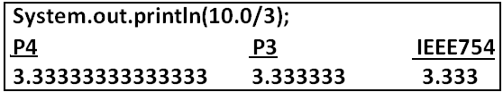
- If a class declares as the Strictfp then every concrete method(which has body) of that class has to follow IEEE754 standard for floating point arithmetic.
What is the difference between abstract and strictfp?
- Strictfp method talks about implementation where as abstract method never talks about implementation hence abstract, strictfp combination is illegal for methods.
- But we can declare a class with abstract and strictfp modifier simultaneously. That is abstract strictfp combination is legal for classes but illegal for methods.
Example:
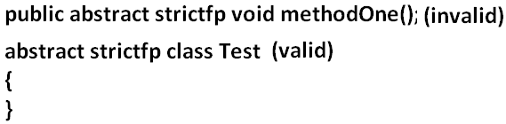
Member modifiers:
Public members:
- If a member declared as the public then we can access that member from anywhere “but the corresponding class must be visible” hence before checking member visibility we have to check class visibility.
Example:

Program 1:
package pack1;
class A
{
public void methodOne(){
System.out.println("a class method");
}}
D:\Java>javac -d . A.java
Program 2:
package pack2;
import pack1.A;
class B
{
public static void main(String args[]){
A a=new A();
a.methodOne();
}}
Output:
Compile time error.
D:\Java>javac -d . B.java
B.java:2: pack1.A is not public in pack1; cannot be accessed from outside package
import pack1.A;
- In the above program even though methodOne() method is public we can’t access from class B because the corresponding class A is not public that is both classes and methods are public then only we can access.
Default member:
- If a member declared as the default then we can access that member only within the current package hence default member is also known as package level access.
Example 1:
Program 1:
package pack1;
class A
{
void methodOne(){
System.out.println("methodOne is executed");
}}

Program 2:
package pack1;
import pack1.A;
class B
{
public static void main(String args[]){
A a=new A();
a.methodOne();
}}
Output:
D:\Java>javac -d . A.java
D:\Java>javac -d . B.java
D:\Java>java pack1.B
methodOne is executed
Example 2:
Program 1:
package pack1;
class A
{
void methodOne(){
System.out.println("methodOne is executed");
}}
Program 2:
package pack2;
import pack1.A;
class B
{
public static void main(String args[]){
A a=new A();
a.methodOne();
}}
Output:
Compile time error.
D:\Java>javac -d . A.java
D:\Java>javac -d . B.java
B.java:2: pack1.A is not public in pack1; cannot be accessed from outside package
import pack1.A;
Private members:
- If a member declared as the private then we can access that member only with in the current class.
- Private methods are not visible in child classes where as abstract methods should be visible in child classes to provide implementation hence private, abstract combination is illegal for methods.
Protected members:
- If a member declared as the protected then we can access that member within the current package anywhere but outside package only in child classes.
- Protected=default+kids.
- We can access protected members within the current package anywhere either by child reference or by parent reference but from outside package we can access protected members only in child classes and should be by child reference only that is we can’t use parent reference to call protected members from outside language.
Example:
Program 1:
package pack1;
public class A
{
protected void methodOne(){
System.out.println("methodOne is executed");
}}
Program 2:
package pack1;
class B extends A
{
public static void main(String args[]){
A a=new A();
a.methodOne();
B b=new B();
b.methodOne();
A a1=new B();
a1.methodOne();
}}
Output:
D:\Java>javac -d . A.java
D:\Java>javac -d . B.java
D:\Java>java pack1.B
methodOne is executed
methodOne is executed
methodOne is executed

Example 2:
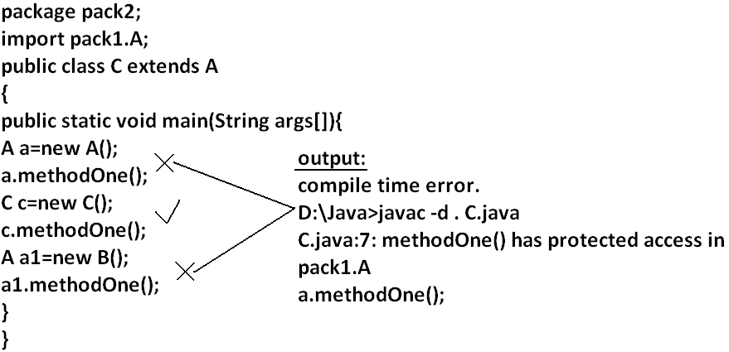
Compression of private, default, protected and public:
visibility | private | default | protected | public
1)With in the same class
2)From child class of same package
3)From non-child class of same package
4)From child class of outside package |  |  | 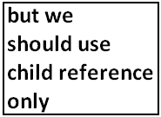
5)From non-child class of outside package
- The least accessible modifier is private.
- The most accessible modifier is public.
- Private<default<protected<public.
- Recommended modifier for variables is private where as recommended modifier for methods is public.
Final variables:
Final instance variables:
- If the value of a variable is varied from object to object such type of variables are called instance variables.
- For every object a separate copy of instance variables will be created.
DIAGRAM:
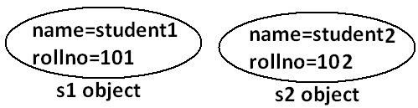
- For the instance variables it is not required to perform initialization explicitly jvm will always provide default values.
Example:
class Test
{
int i;
public static void main(String args[]){
Test t=new Test();
System.out.println(t.i);
}}
Output:
D:\Java>javac Test.java
D:\Java>java Test
0
- If the instance variable declared as the final compulsory we should perform initialization whether we are using or not otherwise we will get compile time error.
Example:
Program 1:
class Test
{
int i;
}
Output:
D:\Java>javac Test.java
D:\Java>
Program 2:
class Test
{
final int i;
}
Output:
Compile time error.
D:\Java>javac Test.java
Test.java:1: variable i might not have been initialized
class Test
Rule:
- For the final instance variables we should perform initialization before constructor completion. That is the following are various possible places for this.
- At the time of declaration:
Example:
class Test
{
final int i=10;
}
Output:
D:\Java>javac Test.java
D:\Java>
- Inside instance block:
Example:
class Test
{
final int i;
{
i=10;
}}
Output:
D:\Java>javac Test.java
D:\Java>
- Inside constructor:
Example:
class Test
{
final int i;
Test()
{
i=10;
}}
Output:
D:\Java>javac Test.java
D:\Java>
- If we are performing initialization anywhere else we will get compile time error.

Example:
class Test
{
final int i;
public void methodOne(){
i=10;
}}
Output:
Compile time error.
D:\Java>javac Test.java
Test.java:5: cannot assign a value to final variable i
i=10;
Final static variables:
- If the value of a variable is not varied from object to object such type of variables is not recommended to declare as the instance variables. We have to declare those variables at class level by using static modifier.
- For the static variables it is not required to perform initialization explicitly jvm will always provide default values.
Example:
class Test
{
static int i;
public static void main(String args[]){
System.out.println("value of i is :"+i);
}}
Output:
D:\Java>javac Test.java
D:\Java>java Test
Value of i is: 0
- If the static variable declare as final then compulsory we should perform initialization explicitly whether we are using or not otherwise we will get compile time error.
Example:
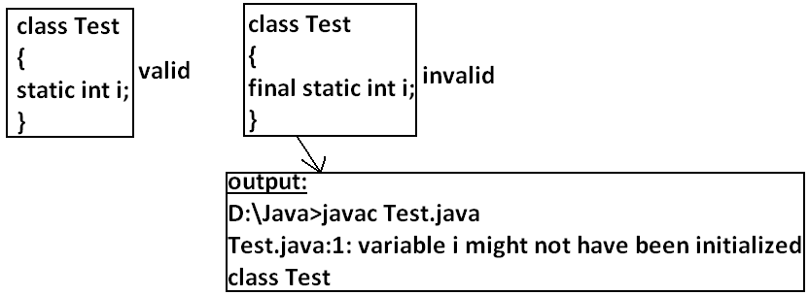
Rule:
- For the final static variables we should perform initialization before class loading completion otherwise we will get compile time error. That is the following are possible places.
- At the time of declaration:
Example:
class Test
{
final static int i=10;
}
Output:
D:\Java>javac Test.java
D:\Java>
- Inside static block:
Example:
class Test
{
final static int i;
static
{
i=10;
}}
Output:
Compile successfully.
- If we are performing initialization anywhere else we will get compile time error.
Example:
class Test
{
final static int i;
public static void main(String args[]){
i=10;
}}
Output:
Compile time error.
D:\Java>javac Test.java
Test.java:5: cannot assign a value to final variable i
i=10;

Final local variables:
- To meet temporary requirement of the programmer sometime we can declare the variable inside a method or block or constructor such type of variables are called local variables.
- For the local variables jvm won’t provide any default value compulsory we should perform initialization explicitly before using that variable.
Example:
class Test
{
public static void main(String args[]){
int i;
System.out.println("hello");
}}
Output:
D:\Java>javac Test.java
D:\Java>java Test
Hello
Example:
class Test
{
public static void main(String args[]){
int i;
System.out.println(i);
}}
Output:
Compile time error.
D:\Java>javac Test.java
Test.java:5: variable i might not have been initialized
System.out.println(i);
- Even though local variable declared as the final before using only we should perform initialization.
Example:
class Test
{
public static void main(String args[]){
final int i;
System.out.println("hello");
}}
Output:
D:\Java>javac Test.java
D:\Java>java Test
hello
Note: The only applicable modifier for local variables is final if we are using any other modifier we will get compile time error.
Example:
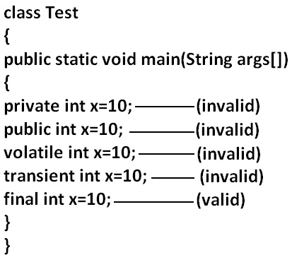
Output:
Compile time error.
D:\Java>javac Test.java
Test.java:5: illegal start of expression
private int x=10;
Formal parameters:
- The formal parameters of a method are simply access local variables of that method hence it is possible to declare formal parameters as final.
- If we declare formal parameters as final then we can’t change its value within the method.
Example:
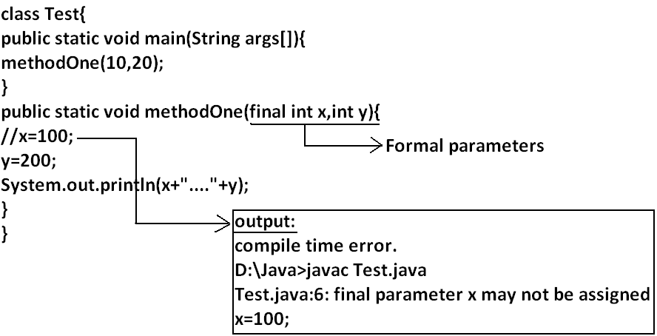
Static modifier:
- Static is the modifier applicable for methods, variables and blocks.
- We can’t declare a class with static but inner classes can be declaring as the static.
- In the case of instance variables for every object a separate copy will be created but in the case of static variables a single copy will be created at class level and shared by all objects of that class.
Example:
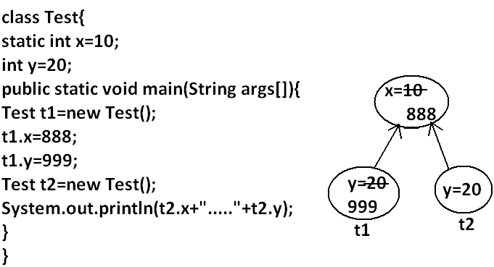
Output:
D:\Java>javac Test.java
D:\Java>java Test
888.....20
- Instance variables can be accessed only from instance area directly and we can’t access from static area directly.
- But static variables can be accessed from both instance and static areas directly.
- Int x=10;
- Static int x=10;
- Public void methodOne(){
System.out.println(x);
}
- Public static void methodOne(){
System.out.println(x);
}
Which are the following declarations are allow within the same class simultaneously?
- 1 and 3
Example:
class Test
{
int x=10;
public void methodOne(){
System.out.println(x);
}}
Output:
Compile successfully.
- 1 and 4
Example:
class Test
{
int x=10;
public static void methodOne(){
System.out.println(x);
}}
Output:
Compile time error.
D:\Java>javac Test.java
Test.java:5: non-static variable x cannot be referenced from a static context
System.out.println(x);
- 2 and 3
Example:
class Test
{
static int x=10;
public void methodOne(){
System.out.println(x);
}}
Output:
Compile successfully.
- 2 and 4

Example:
class Test
{
static int x=10;
public static void methodOne(){
System.out.println(x);
}}
Output:
Compile successfully.
- 1 and 2
Example:
class Test
{
int x=10;
static int x=10;
}
Output:
Compile time error.
D:\Java>javac Test.java
Test.java:4: x is already defined in Test
static int x=10;
- 3 and 4
Example:
class Test{
public void methodOne(){
System.out.println(x);
}
public static void methodOne(){
System.out.println(x);
}}
Output:
Compile time error.
D:\Java>javac Test.java
Test.java:5: methodOne() is already defined in Test
public static void methodOne(){
- Overloading concept is applicable for static method including main method also.
Example:
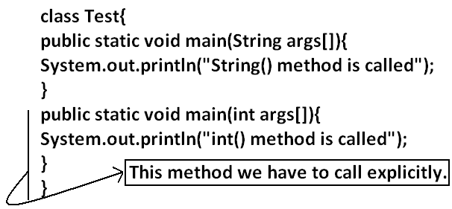
- Inheritance concept is applicable for static methods including main() method hence while executing child class, if the child doesn’t contain main() method then the parent class main method will be executed.
Example:
class Parent{
public static void main(String args[]){
System.out.println("parent main() method called");
}
}
class child extends Parent{
}
Output:
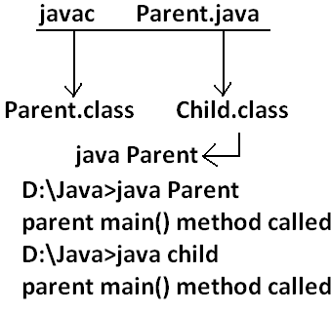
Example:
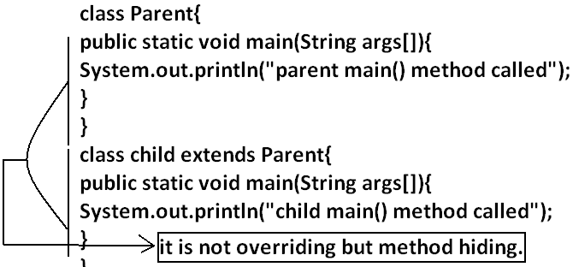
Output:
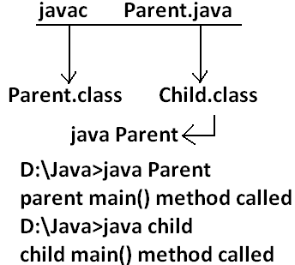
- It seems to be overriding concept is applicable for static methods but it is not overriding it is method hiding.
- For static methods compulsory implementation should be available where as for abstract methods implementation should be available hence abstract static combination is illegal for methods.
Native modifier:
- Native is a modifier applicable only for methods but not for variables and classes.
- The methods which are implemented in non java are called native methods or foreign methods.
The main objectives of native keyword are:
- To improve performance of the system.
- To use already existing legacy non java code.
To use native keyword:

Pseudo code:
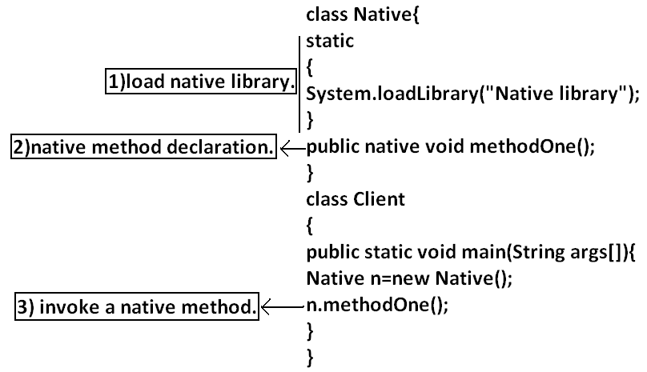
- For native methods implementation is already available and we are not responsible to provide implementation hence native method declaration should compulsory ends with semicolon.
- Public native void methodOne()----invalid
- Public native void methodOne();---valid
- For native methods implementation is already available where as for abstract methods implementation should not be available child class is responsible to provide that, hence abstract native combination is illegal for methods.
- We can’t declare a native method as strictfp because there is no guaranty whether the old language supports IEEE754 standard or not. That is native strictfp combination is illegal for methods.
- For native methods inheritance, overriding and overloading concepts are applicable.
- The main disadvantage of native keyword is usage of native keyword in java breaks platform independent nature of java language.
Synchronized:
- Synchronized is the modifier applicable for methods and blocks but not for variables and classes.
- If a method or block declared with synchronized keyword then at a time only one thread is allow to execute that method or block on the given object.
- The main advantage of synchronized keyword is we can resolve data inconsistency problems, but the main disadvantage is it increases waiting time of the threads and effects performance of the system. Hence if there is no specific requirement never recommended to use synchronized keyword.
Transient modifier:
- Transient is the modifier applicable only for variables but not for methods and classes.
- At the time of serialization if we don’t want to serialize the value of a particular variable to meet the security constraints then we should declare that variable with transient modifier.
- At the time of serialization jvm ignores the original value of the transient variable and save default value that is transient means “not to serialize”.
- Static variables are not part of object state hence serialization concept is not applicable for static variables duo to this declaring a static variable as transient there is no use.
- Final variables will be participated into serialization directly by their values due to this declaring a final variable as transient there is no impact.
Volatile modifier:
- Volatile is the modifier applicable only for variables but not for classes and methods.
- If the value of variable keeps on changing such type of variables we have to declare with volatile modifier.
- If a variable declared as volatile then for every thread a separate local copy will be created by the jvm, all intermediate modifications performed by the thread will takes place in the local copy instead of master copy.
- Once the value got finalized before terminating the thread that final value will be updated in master copy.
- The main advantage of volatile modifier is we can resolve data inconsistency problems, but creating and maintaining a separate copy for every thread increases complexity of the programming and effects performance of the system. Hence if there is no specific requirement never recommended to use volatile modifier and it’s almost outdated.
- Volatile means the value keep on changing where as final means the value never changes hence final volatile combination is illegal for variables.
Modifier | Classes  Outer Inner |  | Methods | Variables | Blocks | Interfaces | Enum | Constructors
Public
Private
Protected
Default
Final
Abstract
Strictfp
Static
Synchronized
Native
Transient
Volatile
Summary of modifier:
- The modifiers which are applicable for inner classes but not for outer classes are private, protected, static.
- The modifiers which are applicable only for methods native.
- The modifiers which are applicable only for variables transient and volatile.
- The modifiers which are applicable for constructor public, private, protected, default.
- The only applicable modifier for local variables is final.

